## PHASE 7: REPORTS & DASHBOARDS

**Report Creation**

Delivery Summary Report

* Report Type: Deliveries
* Grouping: Status (row grouping)
* Columns:
  + Delivery Number
  + Customer Name
  + Assigned Driver
  + Scheduled Date
  + ETA
* Filters:
  + Status not equal to Delivered
  + Scheduled Date within this week

On-time vs Late Report

* Report Type: Deliveries
* Metrics:
  + Count of Deliveries
  + Count of SLA Breaches
* Filters:
  + Created Date this month
  + Status equals Delivered
* Chart: Pie chart visualizing on-time vs late deliveries

Driver Performance Report

* Report Type: Deliveries
* Grouping: Assigned Driver (row grouping)
* Columns:
  + Delivery Count
  + Average Delivery Time
  + On-time Percentage
  + Customer Rating (if available)
* Sorting: Delivery Count, descending

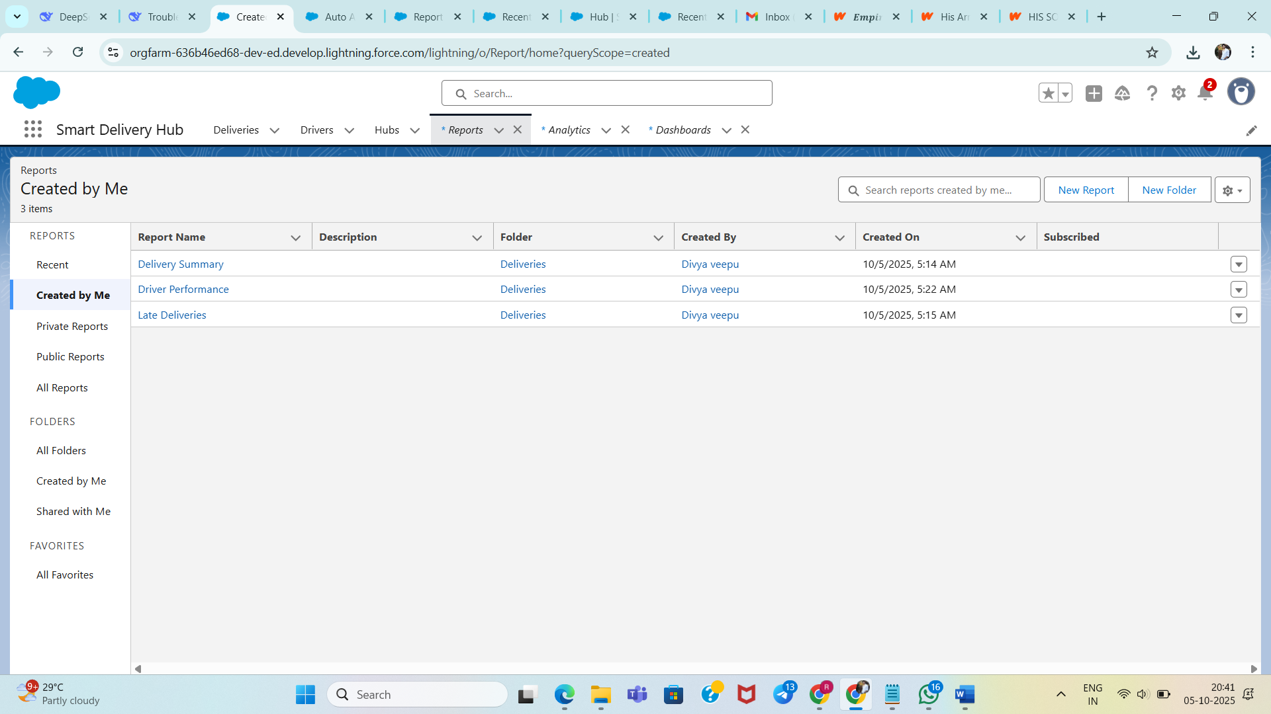

**Dashboard Design**

Dashboard Components

* Component 1: KPI – Total Active Deliveries
  + Metric: Count of deliveries where Status is not Delivered
  + Comparison against previous week
* Component 2: KPI – On-time Delivery Rate
  + Metric: (On-time deliveries / Total deliveries) × 100%
  + Target: 95%
* Component 3: Chart – Deliveries by Status
  + Type: Bar Chart
  + Grouping: Status
  + Timeframe: Current week
* Component 4: Table – Overdue Deliveries
  + Columns: Delivery, Customer, Driver, Delay time
  + Sorted by highest delay

Dashboard Layout

* Top Row: KPI Components (two side-by-side)
* Middle Row: Status Bar Chart (full width)
* Bottom Row: Overdue Deliveries Table (full width)

Automation & Scheduling

* Daily automatic data refresh
* Email distribution scheduled to operations managers
* Full mobile optimization for key metrics and charts

Performance Metrics Tracked

* Operational: Delivery volume, status distribution
* Efficiency: On-time rates, driver utilization
* Customer: SLA compliance, overall delivery times
* Business: Capacity, weekly/monthly trends

